MAC-DONALD ONYEWUCHI EGBUNA

SOPHOS NEXT-GEN FIREWALL

INSTALLATION, CONFIGURATION & SETUP

ALT/SOE/025/4248

# **SOPHOS FIREWALL DOWNLOAD AND PRE INSTALLATION**

**Step 1 : Firewall Installers**

1. Launch a browser (Firefox,chrome or any browser of choice)
2. Visit the Sophos Firewall Installers webpage using the link: <https://www.sophos.com/en-us/support/downloads/firewall-installers>
3. Scroll down and locate the card titled “Virtual Installers: Firewall OS for VMware” and click the contained Download button. This opens the End User.

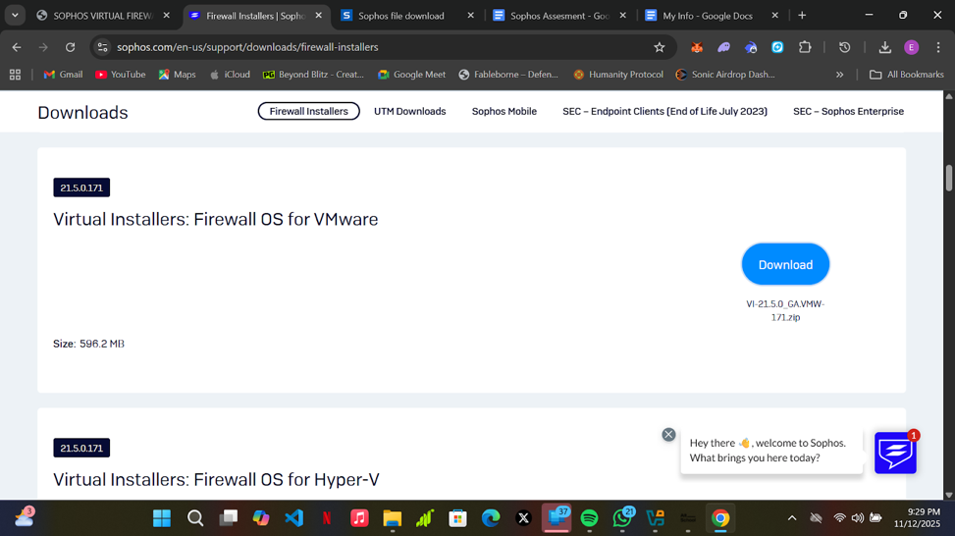

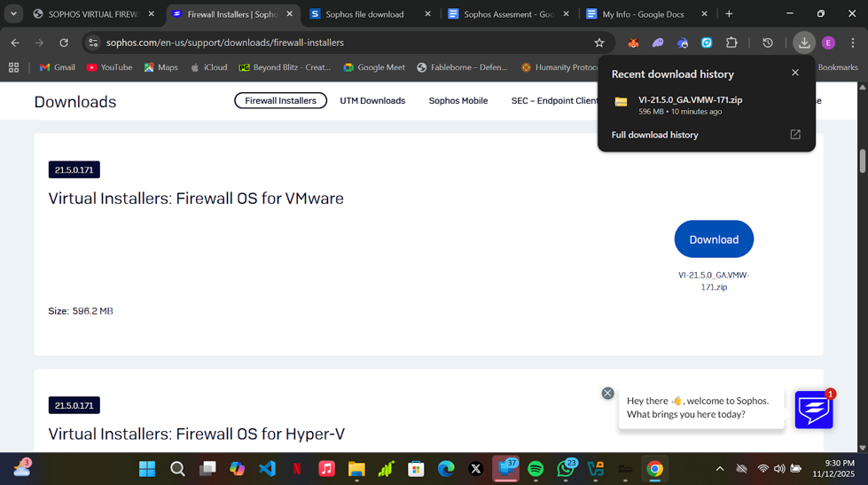

**Step 2: Pre-Installation Setup**

1. Launched the ZIP file, VI-21.5.0_GA.VMW-171.zip, using a file decompressor/extractor software.
2. Extracted the contents of the ZIP file to my desired location

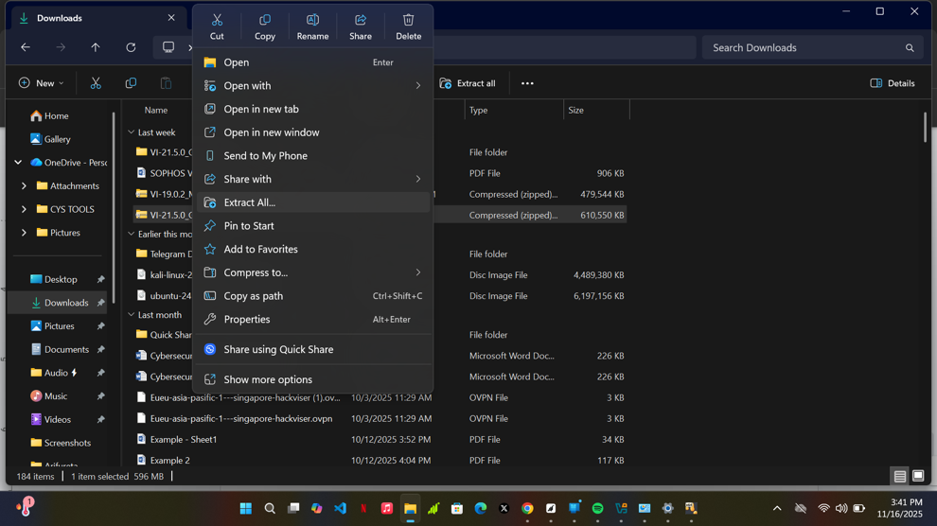

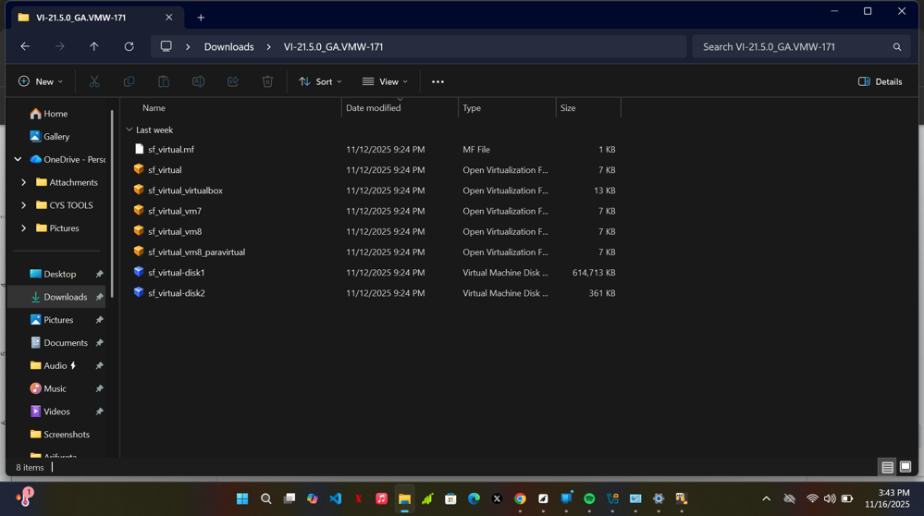

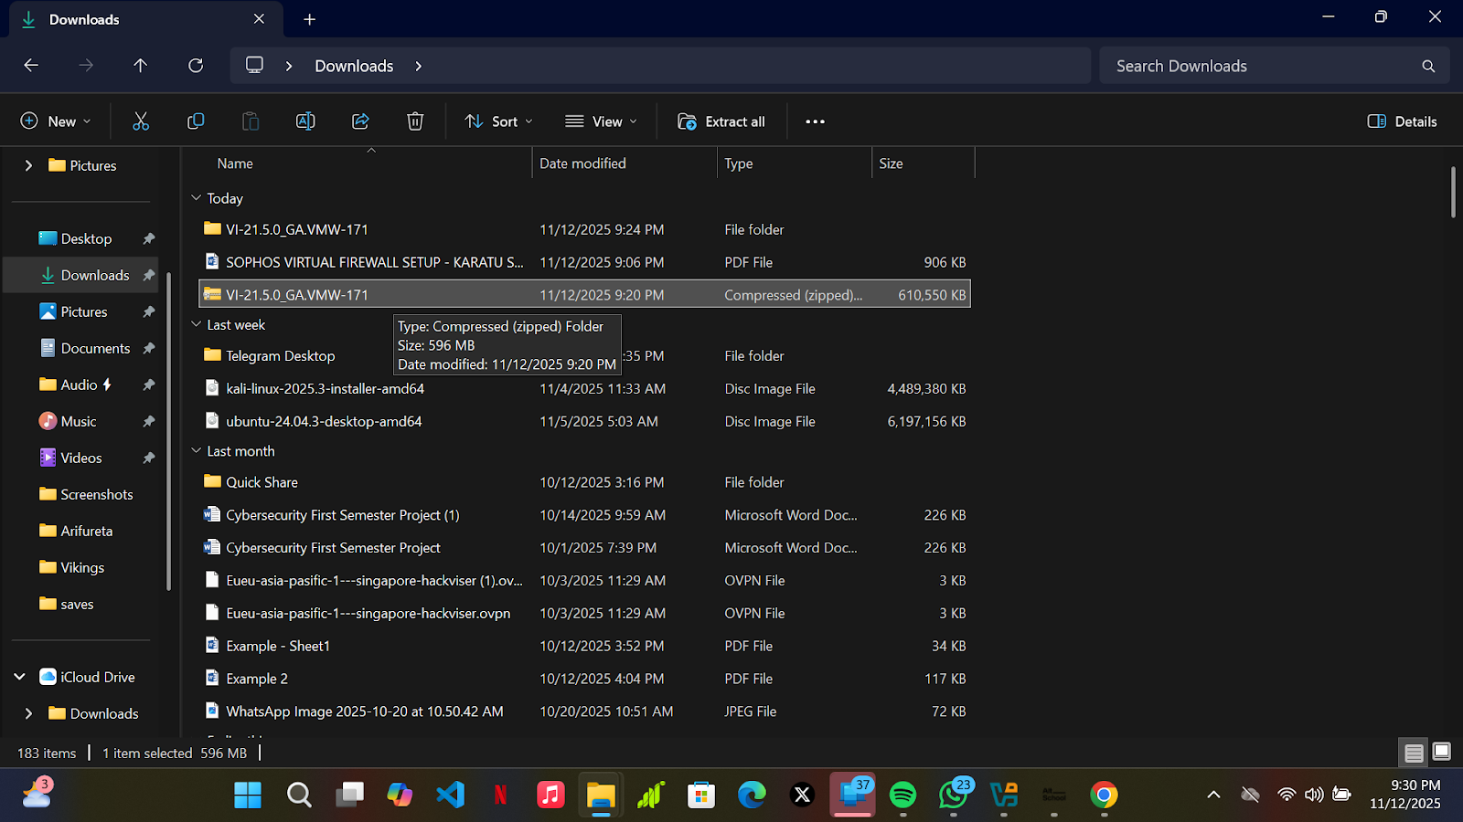

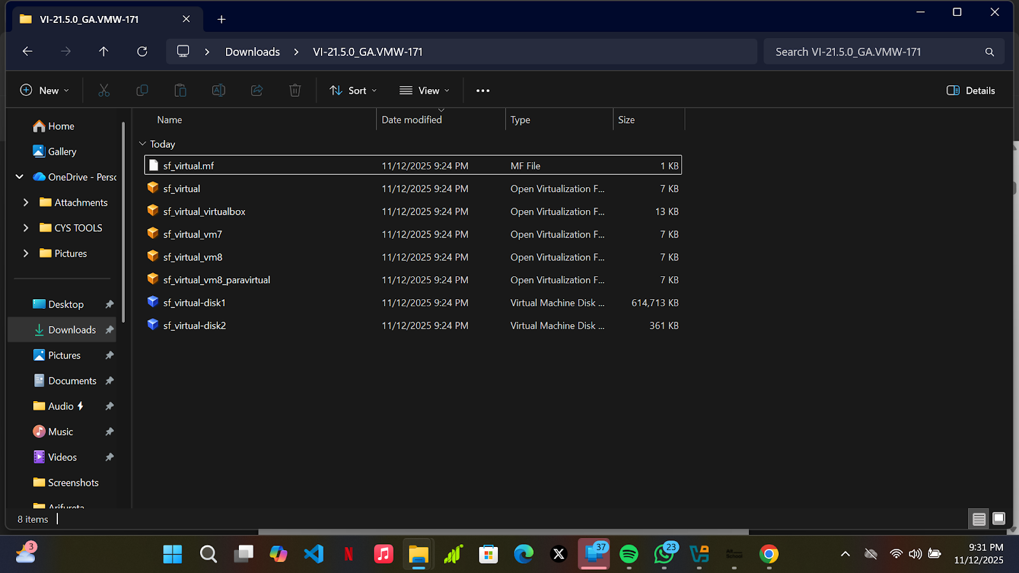

## **Step 3: VIRTUAL BOX NETWORK CONFIGURATION**

**Step 3:**

* Imported the previously downloaded firewall VM
* Open your virtualbox and select “file” at the top-left corner and click on “import appliances”. This is what you will see

* Click on the file icon
* Navigate to where you extracted the sophos’ firewall virtual machine and select sf_virtual_virtualbox.ovf .
* Click on open.
* After clicking on open, click on finish to import the virtual machine in your virtualbox.
* The image below is what you should see after the machine has been imported.*Kindly note that it appears as “Virtual_SF 1” on my virtualbox because I have installed it before. Ideally, it should appear as “Virtual_SF” on your virtualbox*
* Before launching the virtual machine, navigate to File >> Tools >> Network manager.
* Click on Network manager, then click on Host-only Networks, then click on Adapter , select “configure Adapter manually” and insert the IP address and subnet mask verbatim (use the same values)

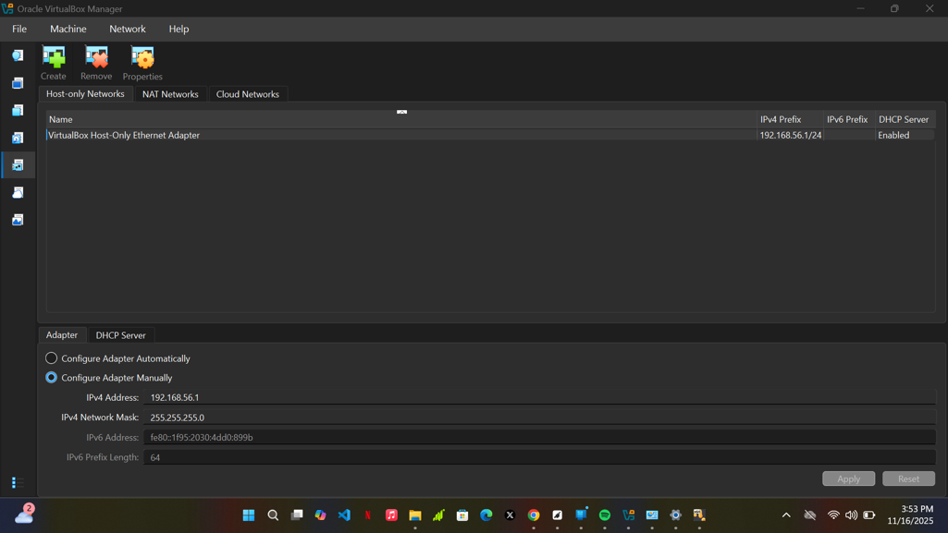

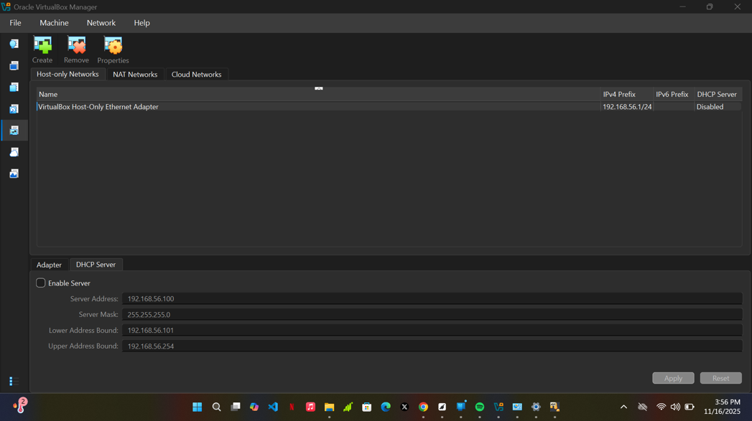

1. Unchecked the DHCP option
2. Configured my IPV4 address to 192.168.56.1
3. Configured the subnet mask to 255.255.255.0

**FIREWALL MACHINE CREATION AND NETWORK CONFIGURATION**

**Step 5:**

* Imported the previously downloaded firewall VM

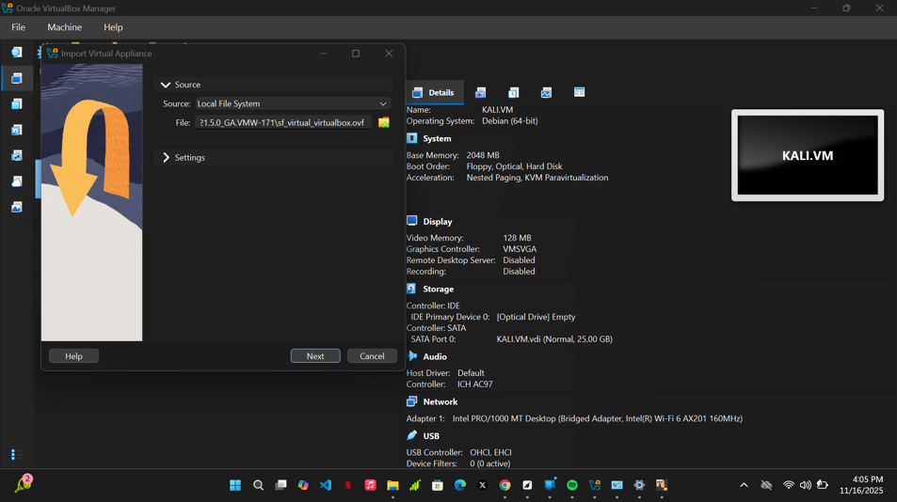

Step 6:

Firewall Network configuration

1. Configured my Adapter1, making to apply the “HOST-ONLY ADAPTER” setting
2. Configured my Adapter 2, making sure to apply “BRIDGED ADAPTER” setting

## **FIREWALL OPERATING SYSTEM SETUP**

1. Launched and installed the Sophos firewall operating system
2. Set the PORT A IP to 192.168.56.201 and the Subnet mask to 255.255.255.0
3. Left the PORT B IP and subnet mask to the default IP and subnet mask.

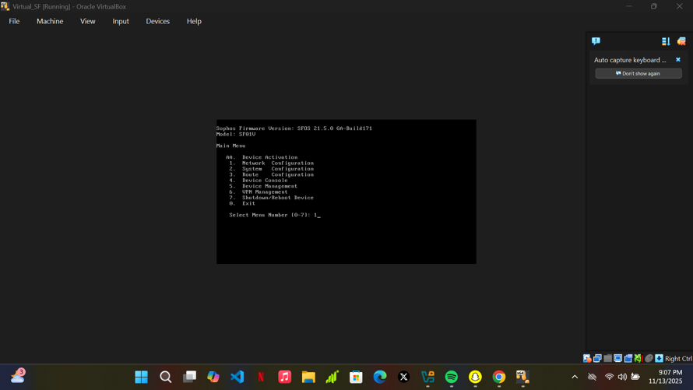

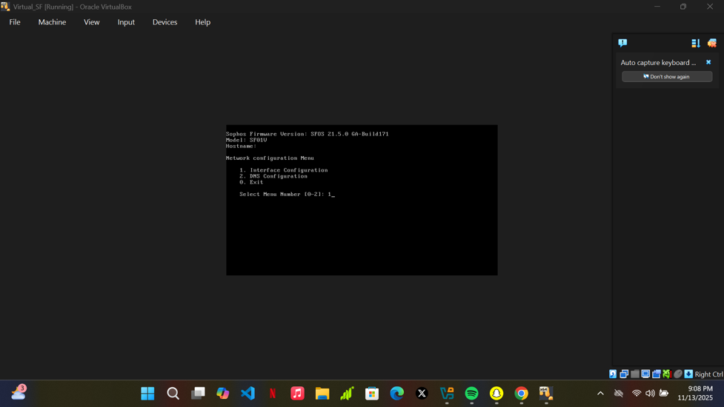

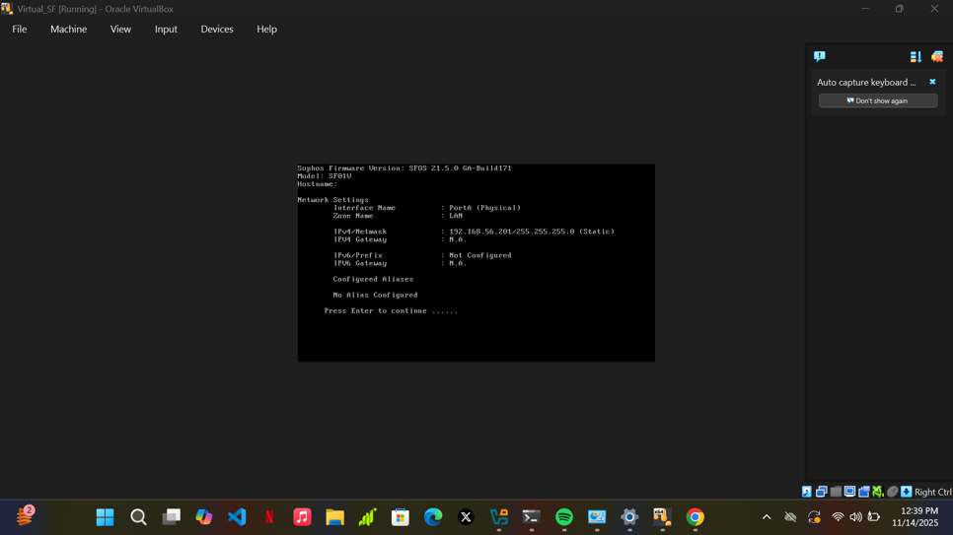

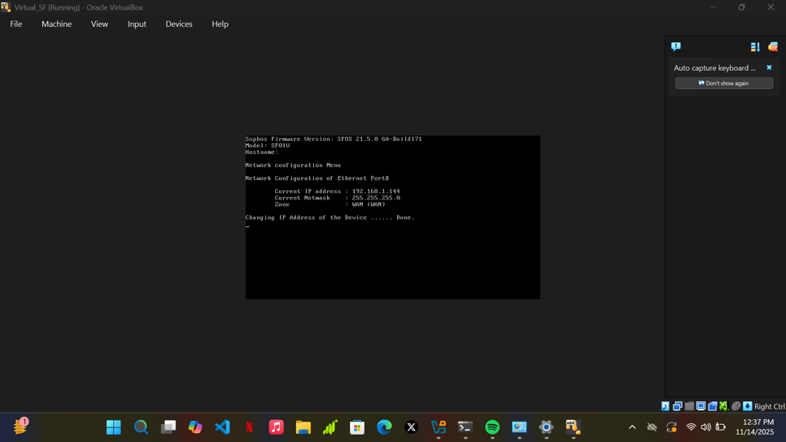

### **SETTING UP FIREWALL IN WEB ADMIN CONSOLE**

At first, after deploying and configuring the sophos firewall, the webpage was not reachable.

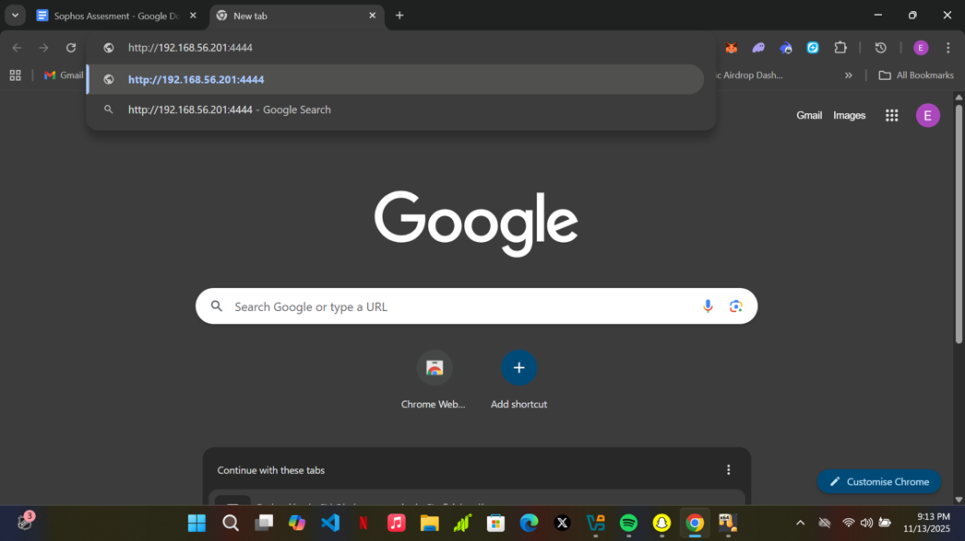

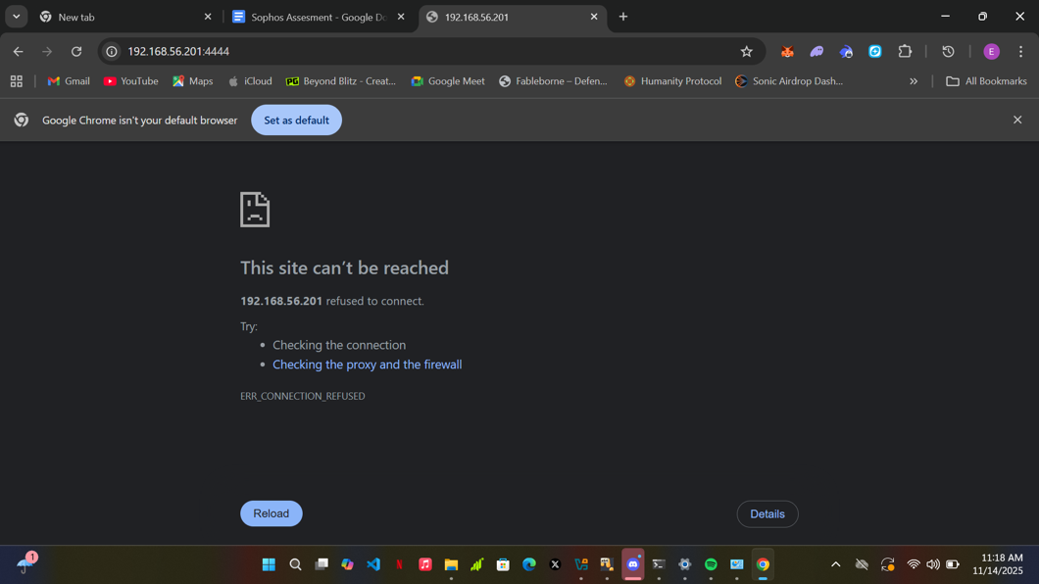

I tried to troubleshoot by making sure the VMnet1 on my host PC had the same IP address as that of the virtual machines, but it had a different IP altogether and I had to reconfigure the IP.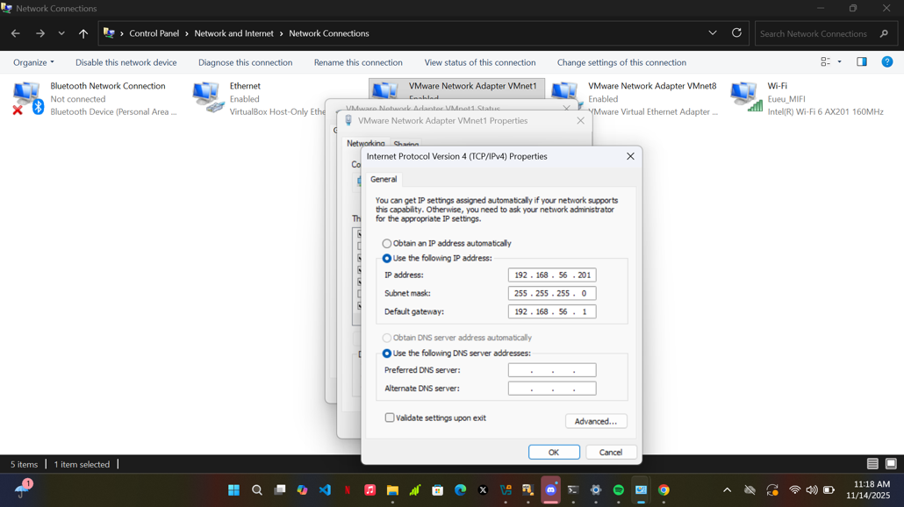

Even after reconfiguring the VMnet1 IP, the web page was still not accessible.

Checked the network connections again and realized that the network adapters were conflicting (VMware and VirtualBox adapter).

To rectify this issue, i disabled **“VMWARE NETWORK ADAPTER** VMnet1” and was able to access the web page of the sophos firewall IP address.

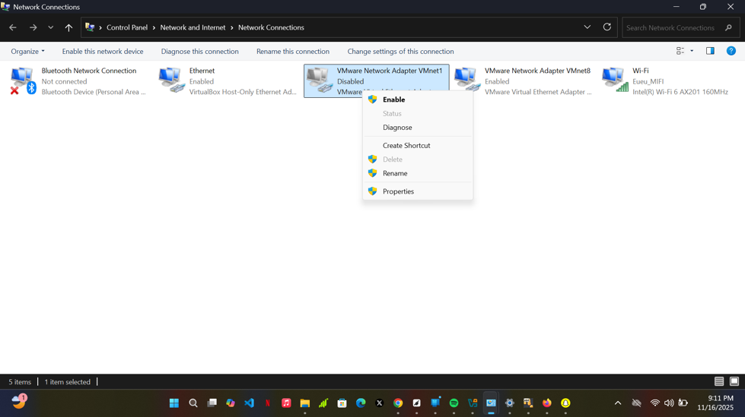

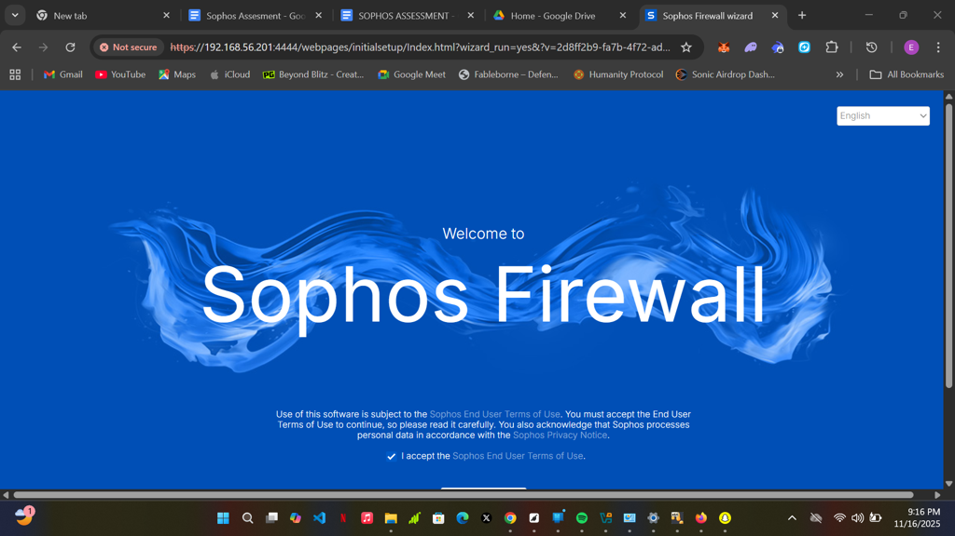

**Basic Configuration setup**

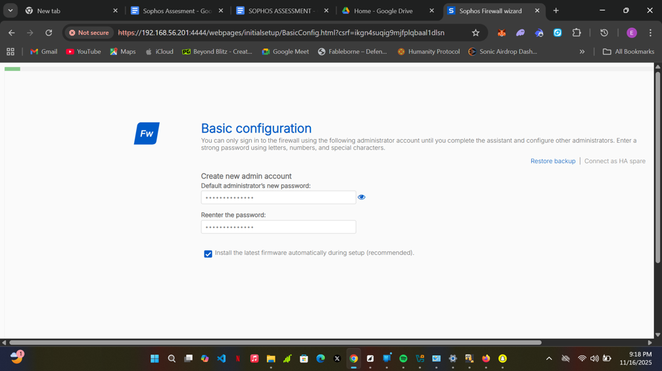

Create a secure storage master key

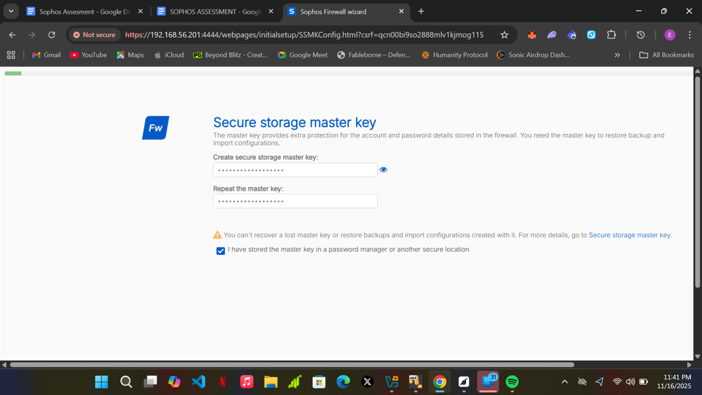

Name and Timezone

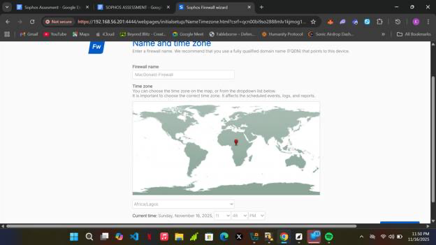

Acquire Serial number for free trial access

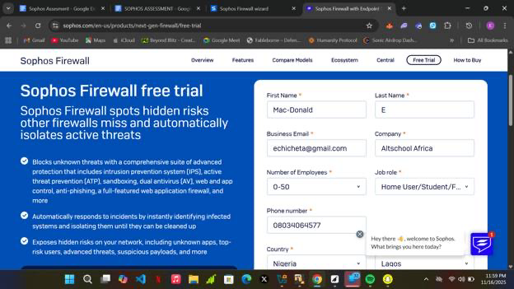

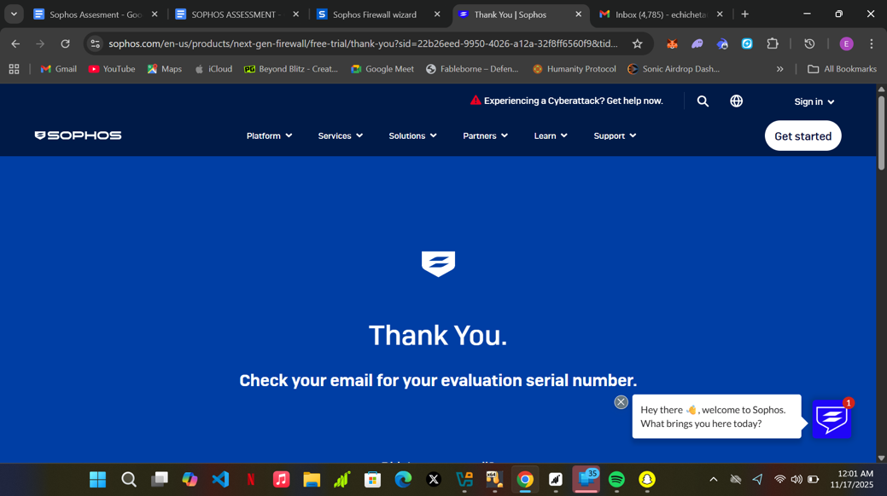

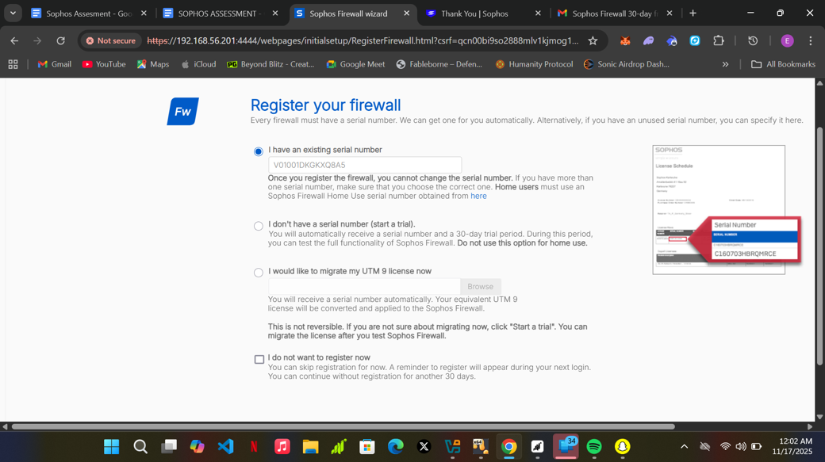

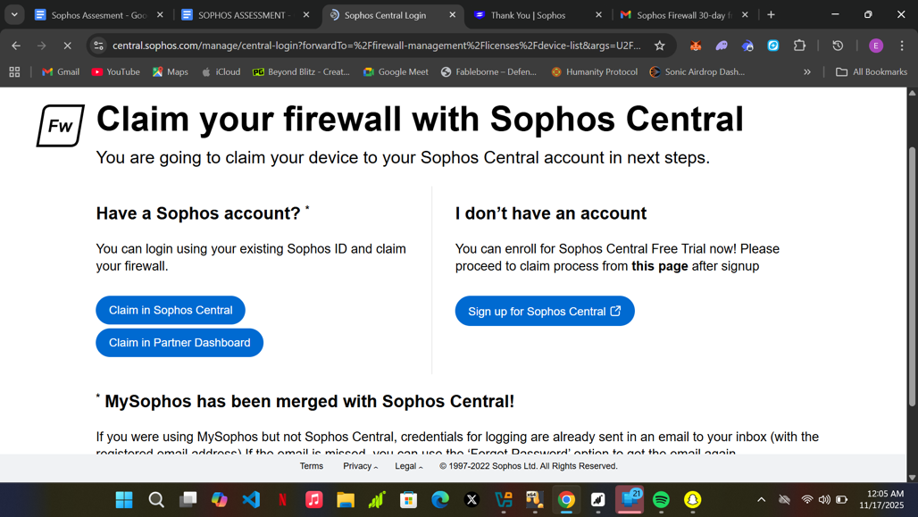

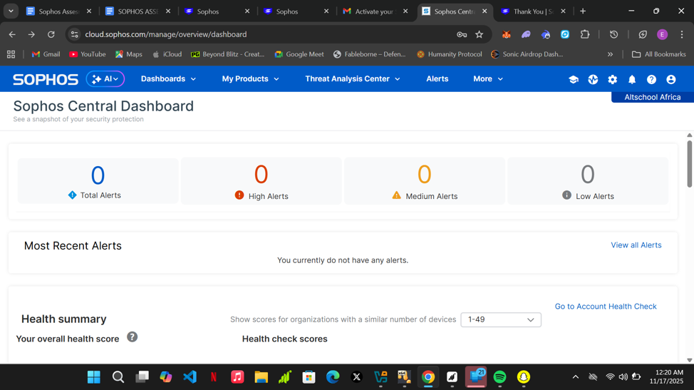

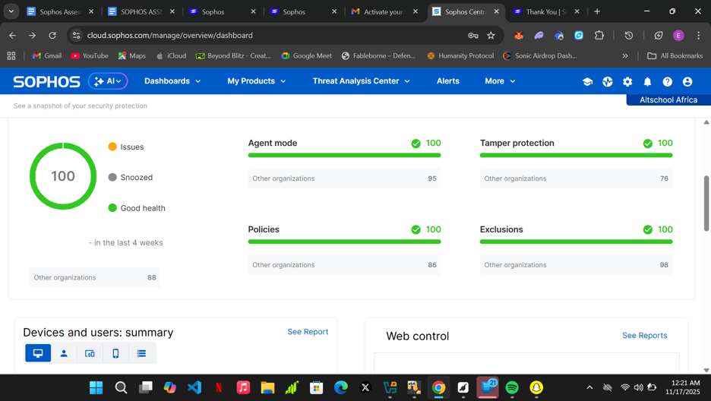

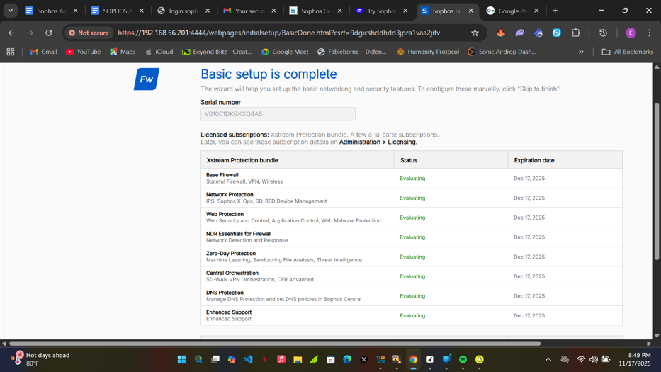

Network Configuration (LAN)

1. Confirmed that the IP in the LAN IP address text box is the same as the previously configured PORTA IP address.
2. Unchecked the DHCP check box and continued

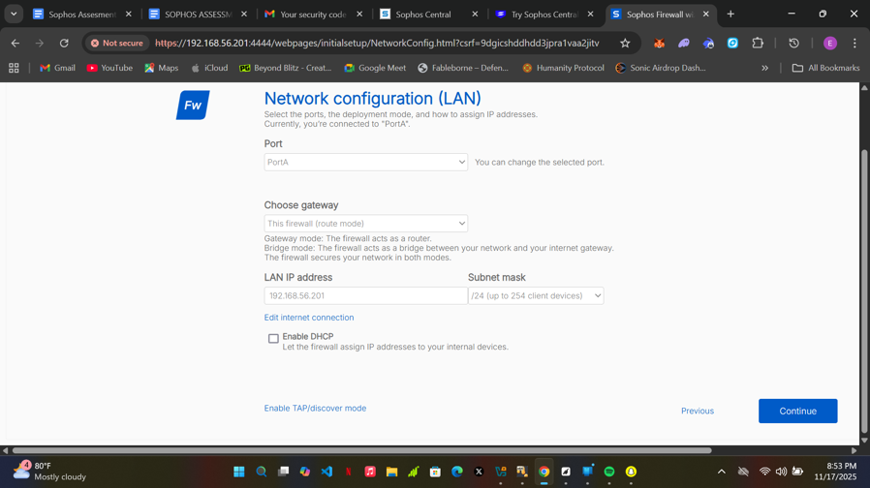

Checked all the boxes on the network protection page

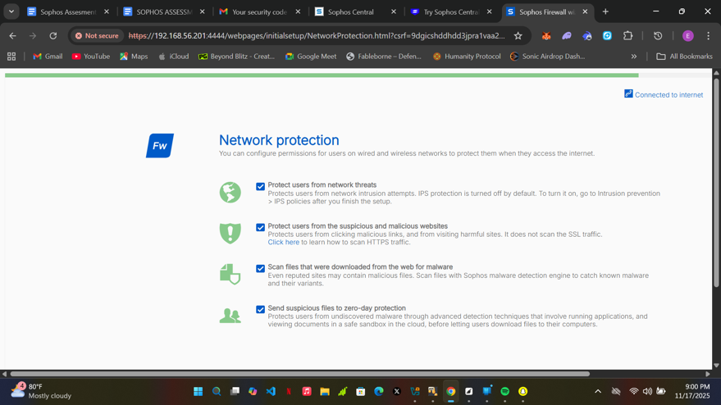

Notifications and Backups page setup

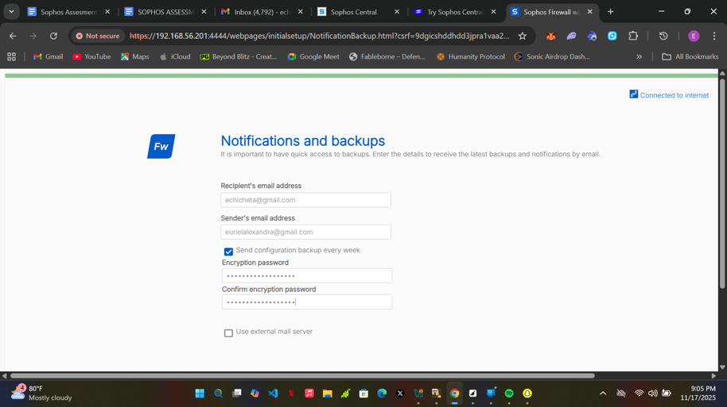

Configuration summary

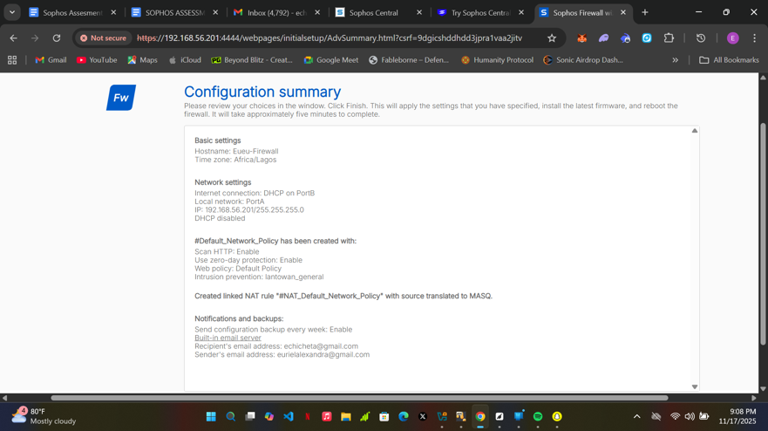

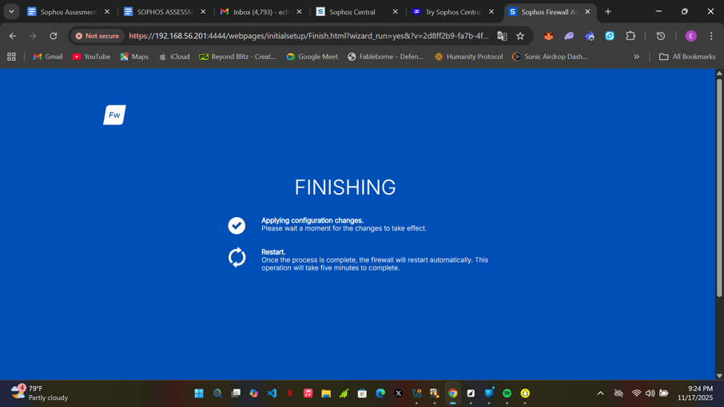

Sign up page

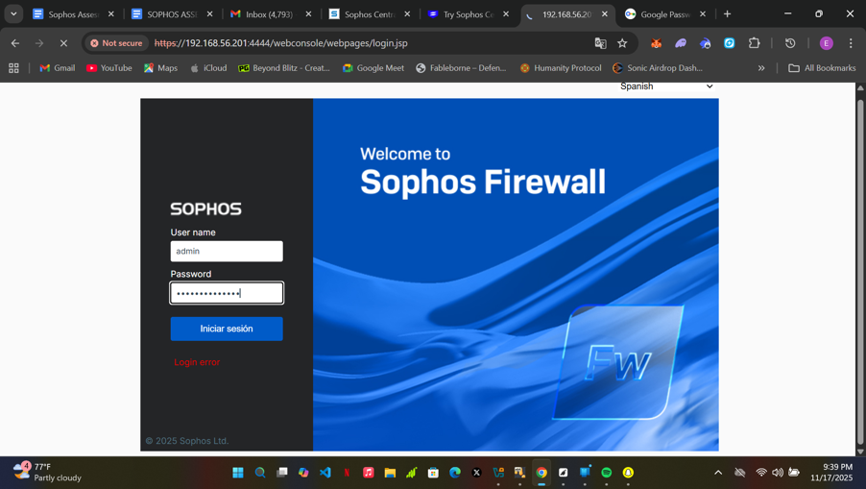

Sophos firewall control center

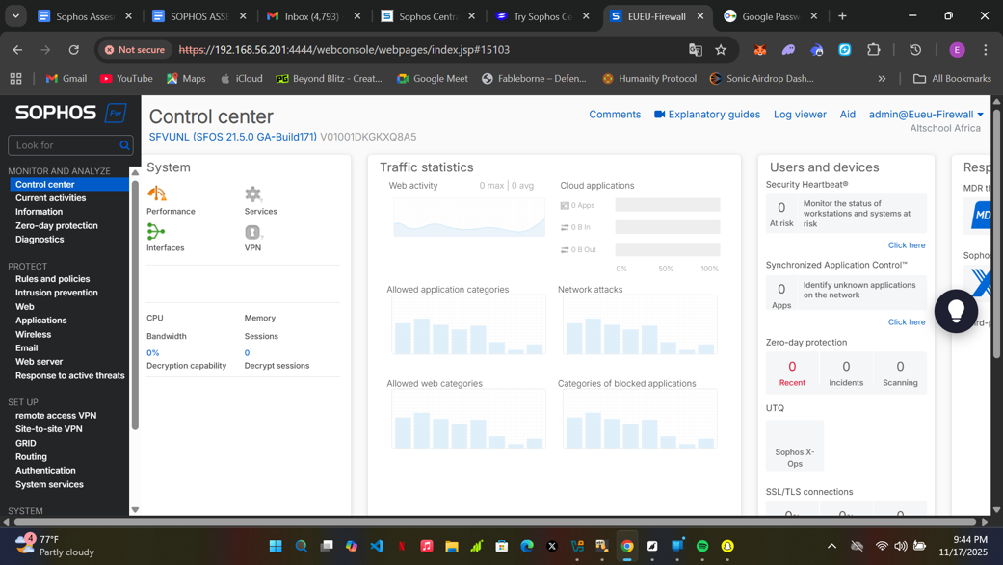

**POLICY CONFIGURATION ON SOPHOS FIREWALL**

**POLICY 1**: Blocking Outbound Web Access for Kali VM (192.168.1.120 )

Step 1:

● On the Sophos Web Console, look at the left sidebar menu.

● Click on Host and services

* Select the ip host tab and click the add button

Define the Kali VM's specific IP address (**192.168.1.120**) as a reusable object named HOST_Kali_192_168_1_120.

● IP version set to **IPv4**

● Type (guy) set to IP

● IP address **192.168.1.120**

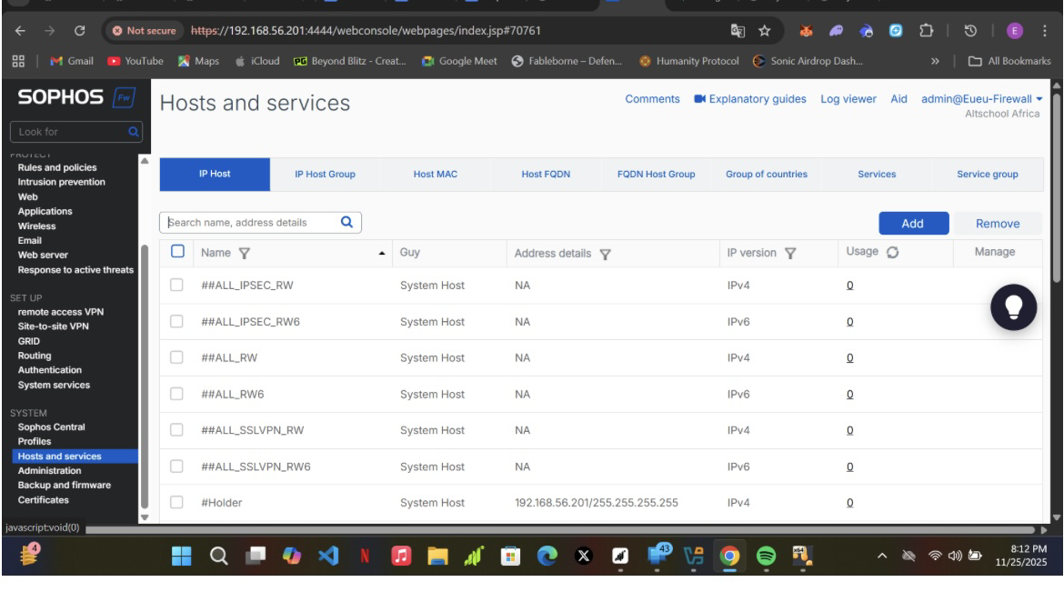

* Select the ip host tab and click the add button
* Define the Kali VM's specific IP address (**192.168.1.120**) as a reusable object named HOST_Kali_192_168_1_120.
* IP version set to **IPv4**
* Type (guy) set to IP
* IP address **192.168.1.120**

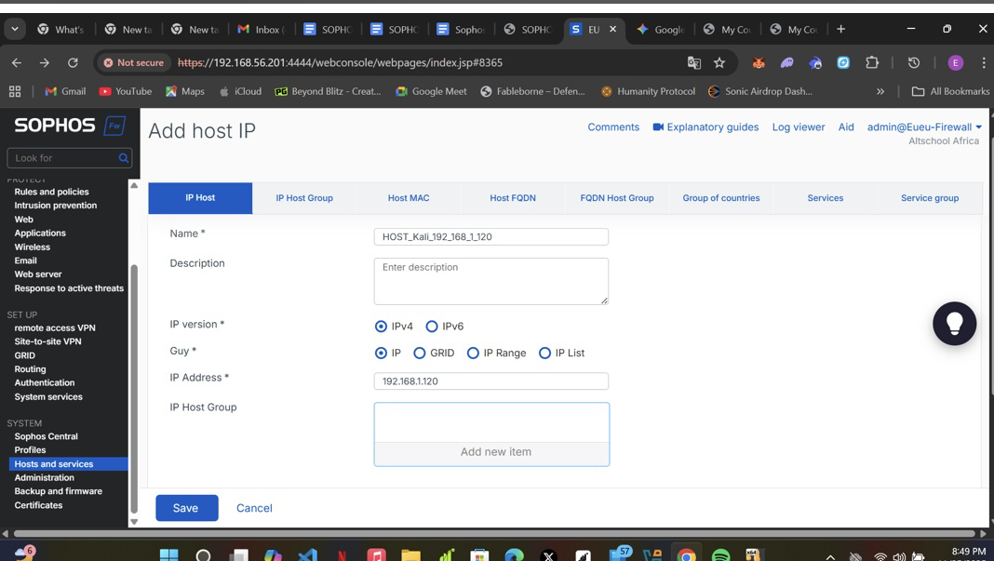

* Click **Save** at the bottom of the window.

Step 2:

* Navigation Path: Rules and Policies**→→**Firewall Rules ➞ Add Firewall Rule ➞ New Firewall Rule

**A.****General Settings**

● Rule name: Should be DROP_Kali_Web_Traffic.

● Action: Select Rule out (This is the silent block/drop action).

● Rule position: Select Top

● Log Firewall Traffic: Check this box (you'll need to scroll down).

**B. Origin (Source Section)**

● Areas of origin: Select LAN Zone.

● Source devices and networks: Select the object HOST_Kali_192_168_1_120.

C. **Destination and services**

● Destination areas: Click Add new item ➞ Search for and select the WAN Zone.

● Destination networks: Click Add new item ➞ Search for and select the object Any.

● Services: Click Add new item ➞ Search for and select the service group Web Browsing

Click the Save button.

● Finally, Analyze the Policy Test Results and confirm the rule set is working

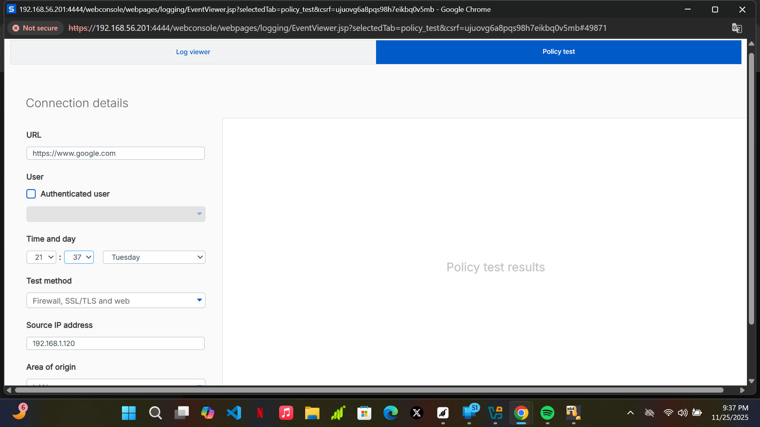

At first the rule configured on the sophos firewall didn't work

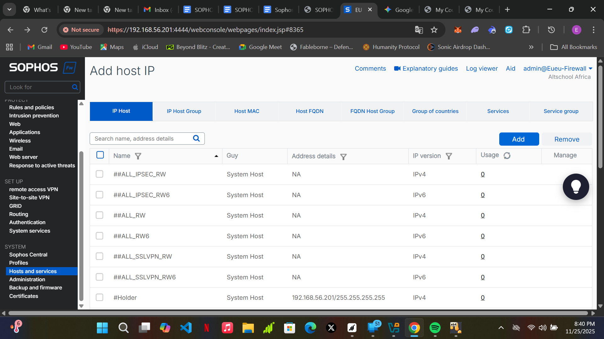

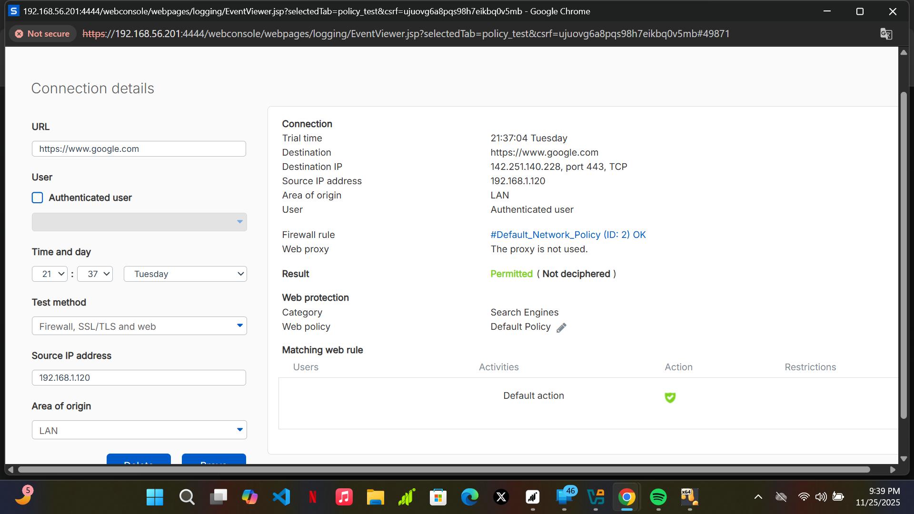

**The Problem: Rule Order**

● My  traffic is matching an existing rule named **Default_Network_Policy** (Rule ID 2) which accepts the traffic, instead of matching the new rule.

**Correcting Policy: Rule Position**

● If the same issue is ecountered edit your **DROP_Kali_Web_Traffic** rule and ensure it is the very first rule to be processed.

● Navigation: Rules and Policies ➟Firewall Rules.

● Action: Find your rule, DROP_Kali_Web_Traffic, and click the Edit icon (pencil).

● Field: Locate Rule Position (or Ruler position in your screenshot).

● Value: Change the current position from whatever it is now (likely "Below" or a low number) to Top (or Above Rule 1 if you have auto-added rules).

● Click Save and try rerunning the test.

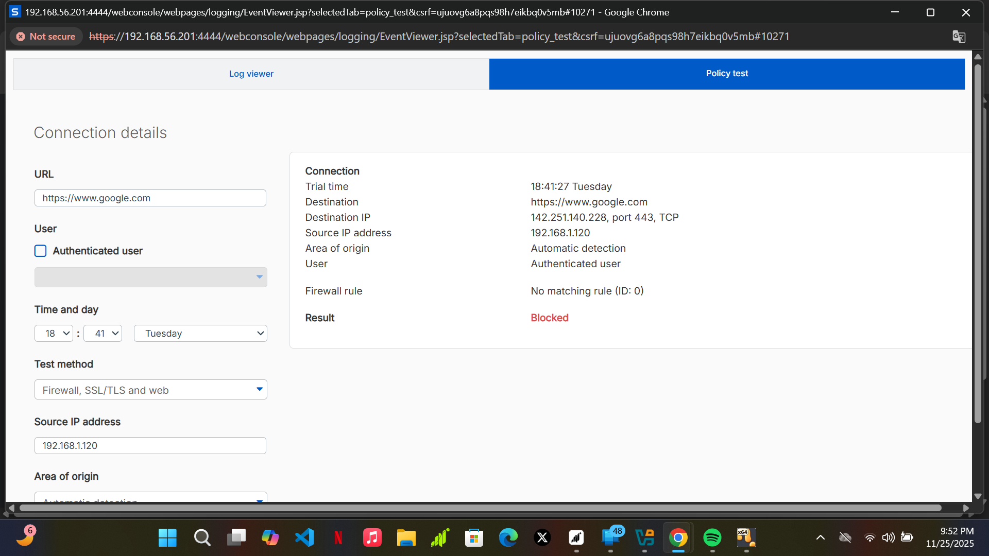

● **"No matching rule (ID: 0)"** followed by the **Result: Blocked** is the Sophos Firewall's way of saying the traffic was blocked by the **Implicit Deny Rule**. (SUCCESS)

**POLICY NUMBER 2**

**Blocking Outbound SSH/Telnet for the LAN**

**Goal:** Prevent any internal host from making remote administrative connections outside the network.

Step 1: Create Service Group

● Hosts and services➞ Service Group➞ Add

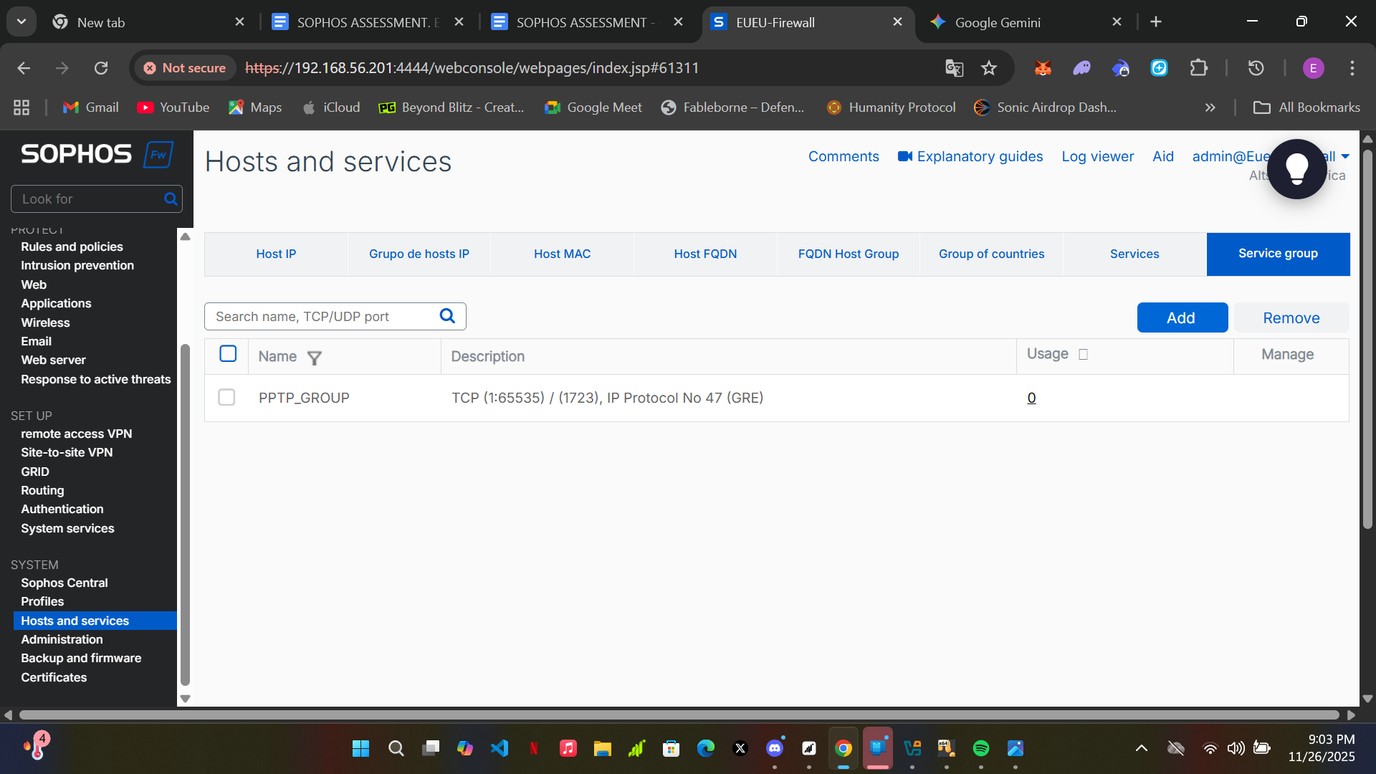

● Description: Group for outbound blocking of SSH (22) and Telnet (23) access for the LAN zone.

● Select service Click Add new item ➞ Select SSH (TCP 22)Adds the Secure Shell protocol and Click Add new item ➟ Select TELNET (TCP 23)

● Save

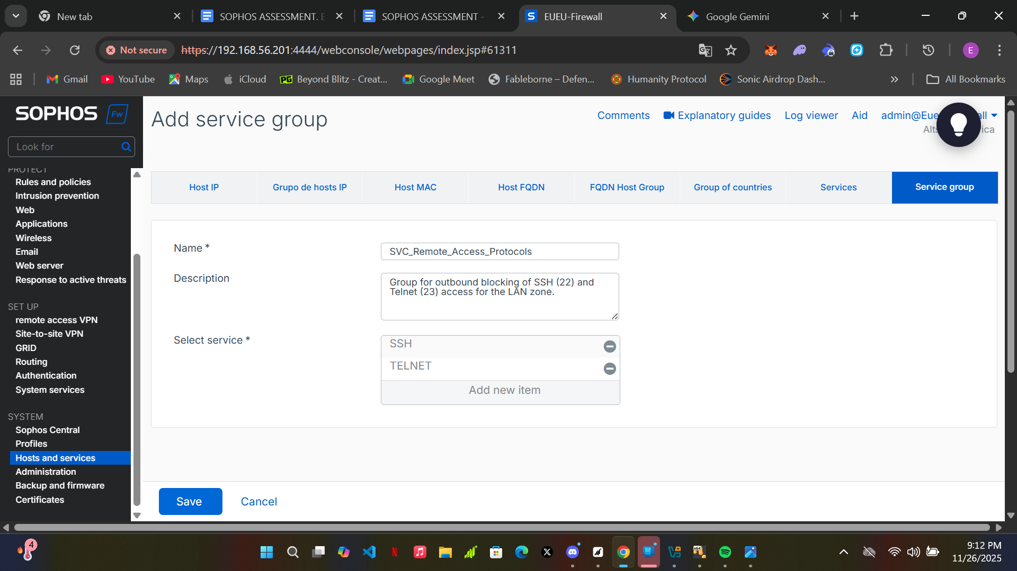

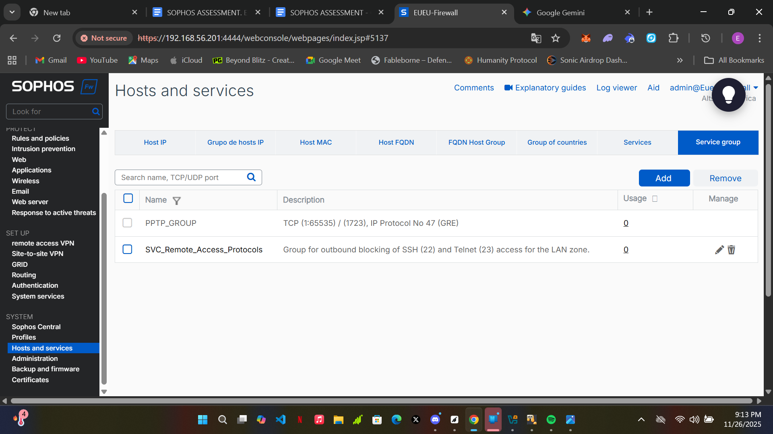

**Step 2: Create the Firewall Rule**

* Navigation Path: Rules and Policies ➞ Firewall Rules ➞ Add Firewall Rule ➞ New Firewall Rule.

**General Settings:**

* Rule Name: DROP_LAN_Outbound_Remote_Access
* Action:Rule out
* Blocks all outbound SSH (TCP 22) and Telnet (TCP 23) traffic originating from the entire LAN zone.
* Log firewall traffic: Check
* Rule set: None

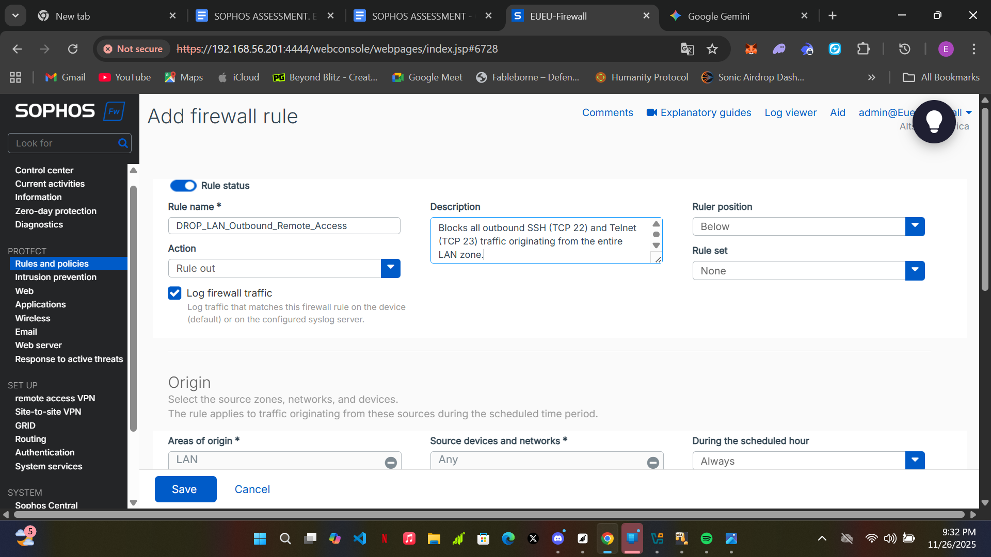

**Origin (Source):**

* Areas of origin:Select LAN
* Source devices and networks: Select Any

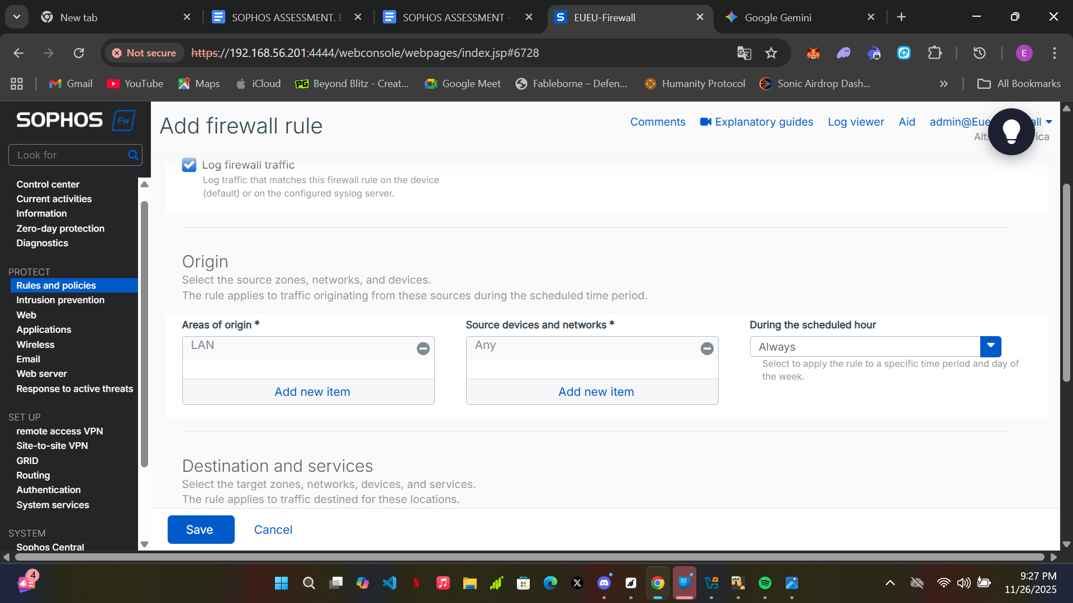

**Destination and Services:**

* Destination areas: Select WAN
* Destination networks: Select Any
* Services: Select SVC_Remote_Access_Protocols
* Click save

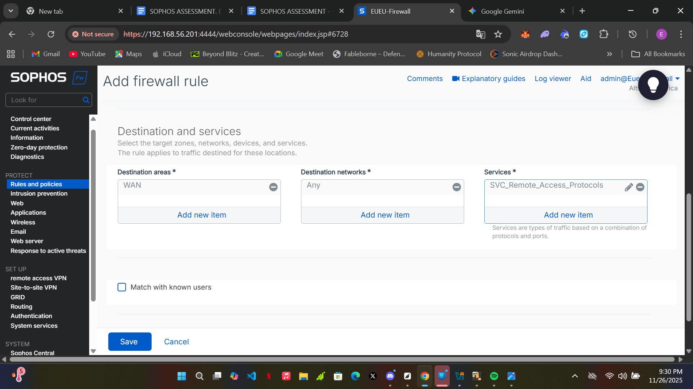

* Analyze the Policy Test Results and confirm the rule set is working

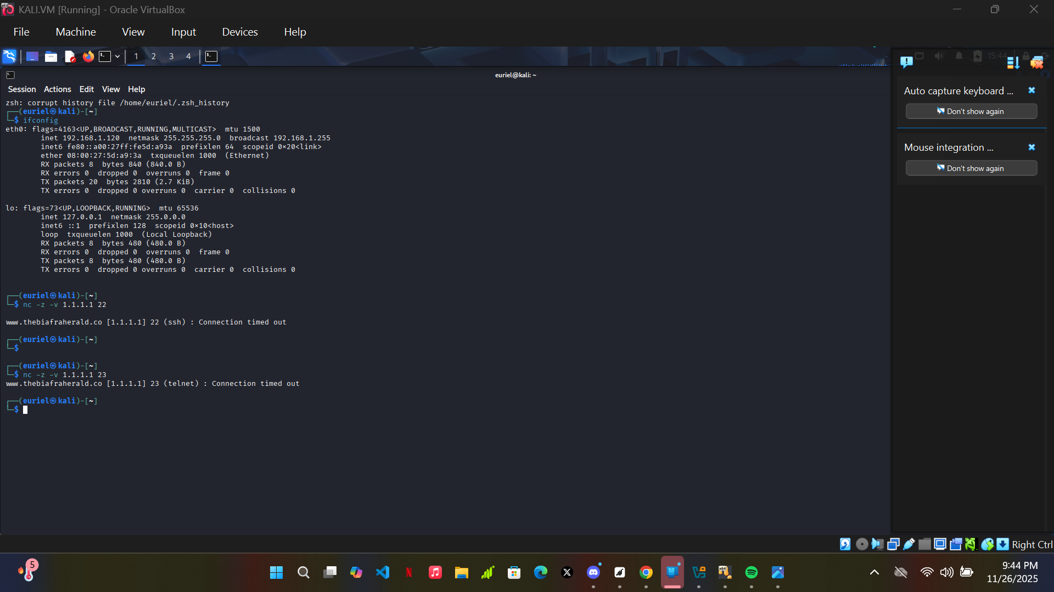

● Using the sophos test your policy icon

